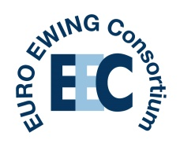
EEC Translational Call – October 2018

Please can you:
- Give your feedback on each of the applications by a) considering whether each one is fits within the remit of the call and b) providing some comments e.g. What strikes you as important about this project?

Thank you for your help with this, it is much appreciated,

EEC Coordination team

Name and title of project | Does this project fit within the remit of the call? (y/n) | Feedback/ comments
Identifying potential treatments for Ewing sarcoma patients based on the genetic and functional characteristics of their tumours

Circulating tumor DNA based analysis of poor prognosis secondary mutations in Ewing sarcoma

Establish the clinical value of the Insulin-like growth factor 2 mRNA binding protein 3 (IGF2BP3)-mediated regulation of the CD164-CXCR4 axis in the metastatic progression of Ewing sarcoma

Functional biomarkers that identify Ewing’s sarcoma patients at increased risk of relapse

Pre-clinical validation of Verteporfin to prevent metastatic spread of Ewing sarcoma

